**WEEK-8**

**5. Git – HOL**

* Explain how to clean up and push back to remote Git

Cleaning up and pushing back to a remote Git repository ensures your local branch is organized, free of unnecessary files, and synchronized with the remote repository.

1. Remove unwanted files – Delete temporary or unnecessary files from the working directory and update .gitignore so they are not tracked in future commits.
2. Delete merged or unused branches – Use git branch -d <branch> to remove branches that have already been merged into master or main.
3. Commit final changes – Stage all relevant changes using git add . and commit with a meaningful message using git commit -m "message".
4. Pull latest changes from remote – Run git pull origin <branch> to ensure your local repository is up to date before pushing.
5. Push changes to remote – Use git push origin <branch> to sync your cleaned-up local branch with the remote repository.

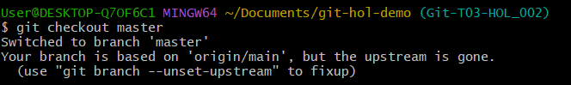

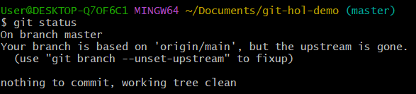

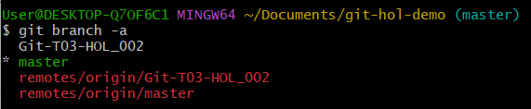

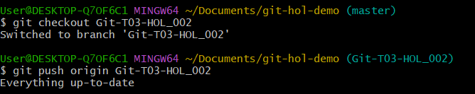

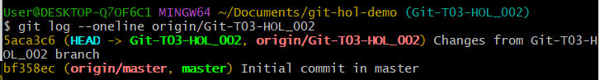

**Explanation:**

* Checked master branch status – Switched to the master branch and confirmed the working directory was clean, meaning there were no pending uncommitted changes.
* Listed all branches – Viewed both local and remote branches to know the current branch setup before pulling from the remote.
* Pulled latest changes – Synced the local master with the remote repository by using git fetch followed by git pull to ensure it had the most up-to-date code.
* Reviewed pending commits – Verified if there were any local commits not yet pushed to the remote by comparing local and remote commit histories.
* Pushed updates to remote – Uploaded any pending local commits from master to the remote repository using git push origin master.
* Confirmed remote sync – Checked the remote repository (via browser or git log) to confirm that the pushed changes were successfully reflected.